AMERICAN PICKERS to Film in Missouri
Mike Wolfe, Frank Fritz, and their team are excited to return to Missouri! They plan to film episodes of the hit series AMERICAN PICKERS throughout your area.
AMERICAN PICKERS is a documentary series that explores the fascinating world of antique ‘picking’ on History. The hit show follows Mike and Frank, two of the most skilled pickers in the business, as they hunt for America’s most valuable antiques. They are always excited to find sizeable, unique collections or accumulations and learn the interesting stories behind them.
As they hit the back roads from coast to coast, Mike and Frank are on a mission to recycle and rescue forgotten relics. Along the way, the Pickers want to meet characters with remarkable and exceptional items. The pair hopes to give historically significant objects a new lease on life, while learning a thing or two about America’s past along the way.
Mike and Frank have seen a lot of rusty gold over the years and are always looking to discover something they’ve never seen before. They are ready to find extraordinary items and hear fascinating tales about them. AMERICAN PICKERS is looking for leads and would love to explore your hidden treasure. If you or someone you know has a large, private collection or accumulation of antiques that the Pickers can spend the better part of the day looking through, send us your name, phone number, location and description of the collection with photos to:
americanpickers@cineflix.com or call 855-OLD-RUST.
facebook: @GotAPick
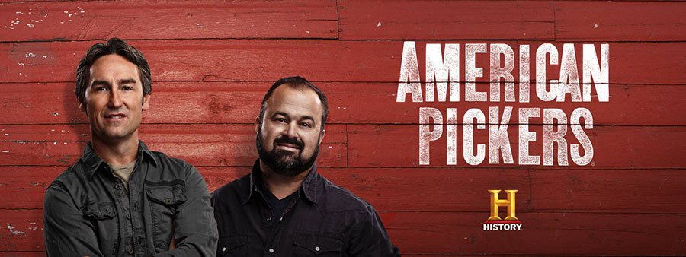
AMERICAN PICKERS is produced by Cineflix Productions for History. New episodes air Mondays at 9pm EST on History.

